Ravela Smyth

CS 516

Professor O’Neal

Assignment 6

Chapter 6 #(3, 4, 6, 7, 8, 9)

3. The j does not need to be reloaded into the accumulator. Since j is being used throughout the loop, it is still in the accumulator at the end of the loop when it branches.

4. Uses CPWA to arrange the three numbers from min to max, and outputs them without spaces.

6.

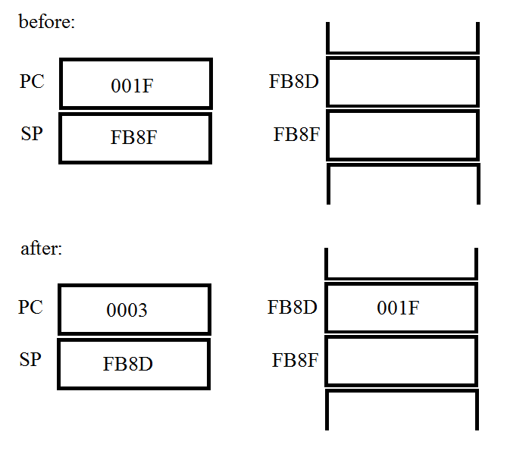

Before the call, PC holds the address of the next line.

After the call, pc holds the address of the first line of the function it called. FB8D holds the address to return to.

7.

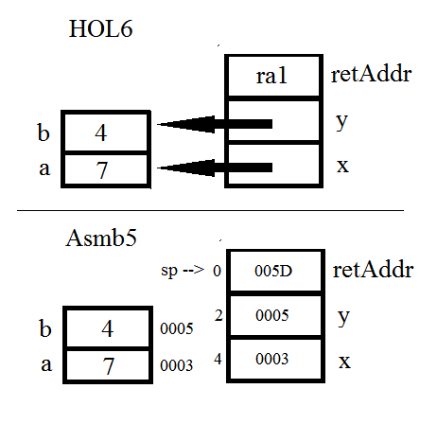

8. Since the address of the “Not close” case is 001B as shown in Pep/9, the code 490049 may be interpreted as STOP by the 00 part of the code. Thus the “Not close” never prints.

9. Make an array that hold addresses of other arrays, using deferred index addressing.